

MSc Data Science Project
7PAM2002
Department of Physics, Astronomy and Mathematics

Data Science FINAL PROJECT REPORT

Project Title:
Heart Disease Risk Prediction Using
Machine Learning

Student Name and SRN:
Renusree Kakarla and 24087145

Supervisor: Klaas Wiersema
Date Submitted: 22/04/2026
Word Count: 3949
GitHub Link: https://github.com/kakarlarenusree/renu_project_Heart-Disease-Risk-Prediction

DECLARATION STATEMENT

This report is submitted in partial fulfilment of the requirement for the degree of Master of Science in Data Science at the University of Hertfordshire.
I have read the detailed guidance to students on academic integrity, misconduct and plagiarism information at Assessment Offences and Academic Misconduct and understand the University process of dealing with suspected cases of academic misconduct and the possible penalties, which could include failing the project or course.
I certify that the work submitted is my own and that any material derived or quoted from published or unpublished work of other persons has been duly acknowledged. (Ref. UPR AS/C/6.1, section 7 and UPR AS/C/5, section 3.6)
I did not use human participants in my MSc Project.

I hereby give permission for the report to be made available on module websites provided the source is acknowledged.

Student Name printed: Renusree Kakarla

Student Name signature : Renusree Kakarla

Student SRN number: 24087145

UNIVERSITY OF HERTFORDSHIRE
SCHOOL OF PHYSICS, ENGINEERING AND COMPUTER SCIENCE

Table of contents:

 | Title | Page Number
 | ABSTRACT | 5
1 | INTRODUCTION | 6
1.1 | Background | 6
1.2 | Motivation | 6
1.3 | Research Question | 6
1.4 | Objectives | 6
2. | LITERATURE REVIEW | 7-8
2.1 | Overview of Existing Studies | 7
2.2 | Comparison of Literature | 8
3. | DATASET | 9-10
3.1 | Dataset Overview | 9
3.2 | Feature Description | 10
3.3 | Missing Values | 10
4. | ETHICAL CONSIDERATIONS | 11
5. | METHODOLOGY | 11-18
5.1 | Data Preprocessing | 11
 | 5.1.1 Handling Categorical Variables | 11
 | 5.1.2 Feature Scaling | 11
 | 5.1.3 Train-Test Split | 11
 | 5.1.4 Final Dataset Preparation | 12
5.2 | Exploratory Data Analysis (EDA) | 12
 | 5.2.1 Univariate Analysis | 12
 | 5.2.2 Bivariate Analysis | 13
 | 5.2.3 Categorical Feature Analysis | 13
 | 5.2.4 Correlation Analysis | 14
 | 5.2.5 Outlier Analysis | 15
5.3 | Model Selection | 15
5.4 | Model Evaluation Metrics | 16
5.5 | Hyperparameter Tuning | 17
5.6 | Explainable AI using SHAP | 18
6. | RESULTS & DISCUSSION | 19-21
6.1 | Model Performance Comparison | 19
6.2 | ROC Curve Analysis | 19
 | 6.2.1 Before Hyperparameter Tuning | 19
 | 6.2.2 After Hyperparameter Tuning | 20
6.3 | Interpretation | 20
6.4 | Key Findings | 21
7. | CONCLUSION | 21
8. | FUTURE WORK | 22
 | REFERENCES | 23
 | APPENDIX | 24-33

ABSTRACT
This project applies machine learning techniques to predict heart disease using the Cleveland Heart Disease dataset. The objective is to develop and evaluate predictive models capable of classifying patients based on clinical attributes and supporting early diagnosis in healthcare applications.
The dataset contains 303 patient records with 14 medical features, including age, chest pain type, cholesterol level, resting blood pressure, and maximum heart rate. Data preprocessing involved handling missing values, feature scaling, and splitting the dataset into training and testing sets.
Three classification models were implemented: Logistic Regression, Random Forest, and XGBoost. These models were selected to represent linear, bagging, and boosting approaches respectively. Model performance was evaluated using accuracy, precision, recall, F1-score, and ROC-AUC to ensure robust assessment, particularly in a medical context where false negatives are critical.
Results show that Random Forest achieved the highest accuracy (87%), while Logistic Regression achieved the highest ROC-AUC (0.95), indicating strong separability of classes. XGBoost achieved similar accuracy (87%) but a lower ROC-AUC (0.89).
Explainable AI using SHAP (SHapley Additive exPlanations) was applied to the tuned XGBoost model to interpret predictions. Key features influencing outcomes included chest pain type, maximum heart rate, and ST depression, aligning with clinical knowledge.
Overall, the study demonstrates that machine learning models can effectively predict heart disease, while SHAP improves interpretability, making the models suitable for healthcare decision support systems.

1.INTRODUCTION
1.1 Background
Heart disease remains one of the leading causes of mortality worldwide, accounting for approximately 17.9 million deaths each year, representing around 32% of all global deaths (World Health Organization, 2023). In the United Kingdom, cardiovascular diseases are responsible for approximately one-quarter of all deaths annually, highlighting their significant impact on public health (British Heart Foundation, 2023).
Early detection and prevention of heart disease are therefore critical challenges in modern healthcare. Advances in data science and machine learning have enabled the development of predictive models that can analyse clinical data and assist in identifying individuals at high risk. These models are capable of capturing complex relationships between medical variables, offering improved diagnostic accuracy compared to traditional statistical methods (Uddin et al., 2019).
This project focuses on predicting the likelihood of heart disease using machine learning techniques applied to structured clinical data. The study utilises the Cleveland Heart Disease dataset, which includes key medical attributes such as age, cholesterol levels, chest pain type, and maximum heart rate. These features are widely recognised as important indicators of cardiovascular health and are commonly used in predictive modelling studies (Detrano et al., 1989; Dua and Graff, 2019).
1.2 Motivation
The motivation for this project is the increasing need for automated healthcare systems capable of assisting clinicians. Machine learning models can analyse large-scale patient data and detect patterns that may not be visible through traditional analysis. This project aims to explore whether ML models can accurately predict heart disease using structured clinical data.
1.3 Research Question:
Can machine learning models accurately predict heart disease risk based on clinical patient data?
1.4 Objectives:
- To perform exploratory data analysis to understand the dataset
- To preprocess the data by handling missing values and preparing features
- To implement and compare multiple machine learning models
- To evaluate model performance using appropriate metrics
- To identify the most important features influencing predictions
2. LITERATURE REVIEW
2.1 Overview of Existing Studies
Heart disease prediction has been widely studied using both traditional statistical approaches and machine learning techniques. Early approaches relied on Logistic Regression due to its simplicity and interpretability; however, its performance is often limited when modelling complex, non-linear relationships in clinical data.
Breiman (2001) introduced the Random Forest algorithm, an ensemble method that improves classification performance by aggregating multiple decision trees. In healthcare applications, Random Forest has demonstrated strong predictive performance, with studies reporting accuracy levels between 85% and 90% for heart disease prediction tasks (Uddin et al., 2019). In their comparative study, Uddin et al. (2019) evaluated multiple classifiers and found that Random Forest achieved an accuracy of 89%, outperforming Logistic Regression, which achieved 82%.
Chen and Guestrin (2016) proposed XGBoost, a gradient boosting algorithm designed for efficiency and scalability. XGBoost has consistently outperformed traditional machine learning models in structured data problems. For example, Yang and Guan (2022) applied XGBoost combined with the Synthetic Minority Over-sampling Technique (SMOTE) to address class imbalance in heart disease datasets, achieving an accuracy of 91% and demonstrating improved sensitivity to minority classes. This highlights the importance of both model selection and data preprocessing in improving predictive performance.
In addition to performance, interpretability is a key requirement in healthcare applications. Lundberg and Lee (2017) introduced SHAP (SHapley Additive exPlanations), which provides a unified framework for explaining model predictions by assigning importance values to each feature. This method enhances transparency and allows clinicians to understand the contribution of individual variables, addressing one of the main limitations of complex ensemble models.
Other studies have also demonstrated the effectiveness of machine learning in heart disease prediction. Bashir et al. (2020) reported that ensemble methods achieved accuracy improvements of approximately 5–10% compared to traditional models, reinforcing the advantage of combining multiple learners to capture complex feature interactions.
While deep learning approaches such as CheXNet (Rajpurkar et al., 2017) have achieved high performance in medical imaging tasks, their applicability to structured datasets is limited due to the relatively small size of datasets such as the Cleveland Heart Disease dataset. Furthermore, deep learning models require significant computational resources and often lack interpretability, making them less suitable for clinical decision support systems.
Overall, the literature demonstrates that ensemble models such as Random Forest and XGBoost consistently outperform traditional models like Logistic Regression by a margin of approximately 5–10% in accuracy. However, this improvement comes at the cost of reduced interpretability. This study builds upon existing work by combining high-performance ensemble models with explainability techniques such as SHAP, ensuring both predictive accuracy and model transparency.
2.2 Comparison of Literature
Study | Model/Method | Technique | Performance | Key Findings | Limitations
Logistic Regression (baseline) | Logistic Regression | Linear statistical model | ~82% accuracy (Uddin et al., 2019) | Simple and interpretable baseline model | Limited ability to capture non-linear relationships
Chen & Guestrin (2016); Yang & Guan (2022) | XGBoost | Gradient boosting framework | 91% accuracy (with SMOTE) | High accuracy and strong performance on structured data | Computationally intensive; lower interpretability
Bashir et al. (2020) | Ensemble methods | Multiple classifier fusion | 5–10% improvement over traditional models | Captures complex feature interactions effectively | Reduced transparency of decision process
Breiman (2001); Uddin et al. (2019) | Random Forest | Ensemble of decision trees | ~85–90% accuracy; 89% reported | Strong predictive performance and robustness | Reduced interpretability compared to linear models
Rajpurkar et al. (2017) | Deep Learning (CheXNet) | Convolutional Neural Networks | High performance in imaging tasks | Effective in medical image classification | Not suitable for small structured datasets; low interpretability

DATASET
3.1 Dataset Overview
The dataset used in this project is the Cleveland Heart Disease dataset, which is widely used for supervised machine learning tasks involving classification of heart disease presence. The dataset was originally collected by the Cleveland Clinic Foundation in 1988 for medical research purposes. It is publicly available through the Kaggle Machine Learning Repository and the UCI Machine Learning Repository.
The original dataset consists of 76 attributes collected from 303 patients. However, most research studies, including this project, use a reduced subset of 14 clinically relevant features, including the target variable. These features represent key medical indicators such as age, sex, chest pain type, resting blood pressure, serum cholesterol level, fasting blood sugar, electrocardiographic results, maximum heart rate achieved, exercise-induced angina, ST depression, slope of ST segment, number of major vessels, and thalassemia condition.
The target variable represents the diagnosis of heart disease. In the original dataset, it is represented using five classes (0 to 4), where 0 indicates no disease and values 1–4 indicate varying severity of heart disease. For classification purposes, this dataset is commonly transformed into a binary classification problem, where:
- 0 = No heart disease
- 1 = Presence of heart disease
The dataset exhibits class imbalance, with a higher number of non-disease cases compared to disease cases. This makes it suitable for evaluating model robustness and performance using multiple evaluation metrics.
3.2 Feature Description
Although the original dataset contains 76 attributes, many features contain missing values or are not clinically significant. Therefore, most studies utilise a reduced subset of 14 features, which capture the most relevant clinical indicators of heart disease. This reduction improves model performance by eliminating noise, reducing dimensionality, and enhancing generalisation.

A summary of the dataset features is provided in Table 1.
Order | Feature | Description | Value Range
1 | Age | Age of patient | 29-77
2 | Sex | Gender | 0=female,1=male
3 | Cp | Chest pain type | 0-3
4 | Trestbps | Resting blood pressure | 94-200 mmHg
5 | Chol | Serum cholesterol | 126-564 mg/dL
6 | Fbs | Fasting blood sugar | 0-1
7 | Restecg | ECG results | 0-2
8 | Thalach | Maximum heart rate achieved | 71-202
9 | Exang | Exercise-induced angina | 0-1
10 | Oldpeak | ST depression | 0-6.2
11 | Slope | ST segment slope | 0-2
12 | Ca | Number of major vessels | 0-3
13 | Thal | Thalassemia condition | 0-2
14 | Target | Heart disease diagnosis | 0-1

3.3 Missing Values
The dataset contains a small number of missing values. Specifically, 6 missing values are present in total, including 4 missing values in the “Ca” feature and 2 missing values in the “Thal” feature. Since the number of missing values is very small compared to the total dataset size, these values were handled using mean imputation to maintain data integrity without removing valuable records.
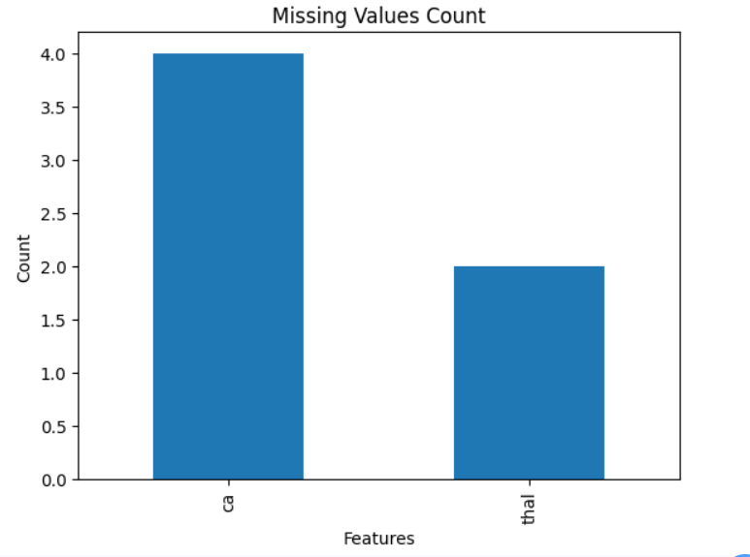
Figure 1: Missing Values Count for Features in the Dataset
4. ETHICAL CONSIDERATIONS
The dataset is anonymised and publicly available. However, predictive models in healthcare must be used responsibly. Machine learning outputs should not replace medical professionals. Bias in datasets may lead to unequal performance across populations. This model is intended for academic use only.
5.METHODOLOGY
5.1 Data Preprocessing
Data preprocessing was performed to prepare the dataset for machine learning models. This involved handling categorical variables, scaling numerical features, and splitting the dataset.
5.1.1 Handling Categorical Variables
Categorical variables such as chest pain type, sex, fasting blood sugar, exercise-induced angina, slope, and thalassemia were already encoded numerically in the dataset. Therefore, no additional encoding was required. These integer values were retained as they represent discrete categories.
5.1.2 Feature Scaling
Numerical features including age, resting blood pressure, cholesterol, maximum heart rate, and ST depression were scaled using StandardScaler. Scaling ensures that features with larger ranges do not dominate model training, particularly for Logistic Regression.
5.1.3 Train-Test Split
The dataset was split into training and testing sets using an 80:20 ratio. The training set was used to fit the models, while the test set was used for evaluation. This approach ensures that model performance is assessed on unseen data.
5.1.4 Final Dataset Preparation
After preprocessing, all features were numeric and standardised. The processed dataset was then used for training Logistic Regression, Random Forest, and XGBoost models.
5.2 Exploratory Data Analysis (EDA)
Exploratory Data Analysis (EDA) was conducted to understand the structure of the dataset, identify patterns, detect anomalies, and guide preprocessing and model selection. The analysis included univariate analysis, bivariate analysis, categorical feature analysis, correlation analysis, and outlier detection.
5.2.1 Univariate Analysis
Univariate analysis was performed to examine the distribution of individual features. Histograms were generated for numerical variables such as age, cholesterol, resting blood pressure, maximum heart rate, and ST depression.
The distribution of age appeared approximately normal, indicating balanced representation across age groups. Cholesterol values showed right-skewness, suggesting the presence of higher cholesterol levels in a subset of patients. Maximum heart rate displayed a wide distribution, which may contribute significantly to classification. ST depression values were concentrated at lower levels, indicating that severe ST depression occurs less frequently.
These observations helped determine that feature scaling would be necessary for numerical variables to ensure consistent model performance.
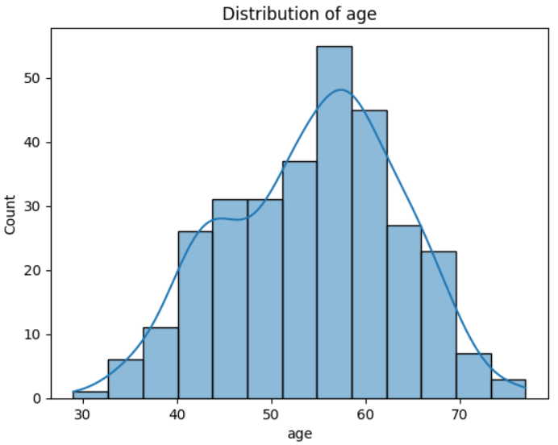 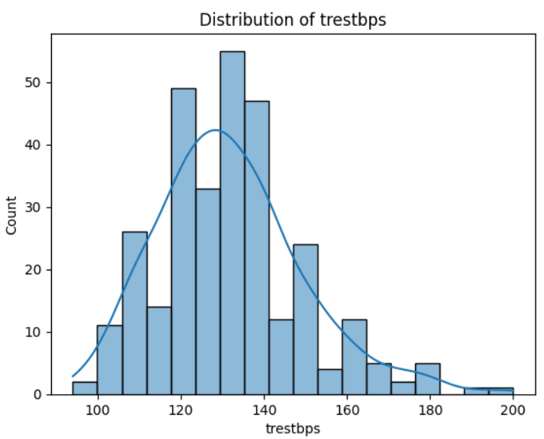Figure2: Distribution of age Figure3: Distribution of Resting
Blood Pressure

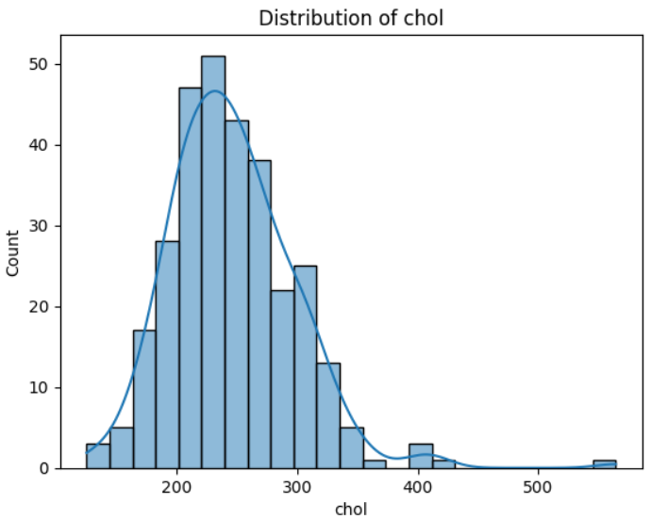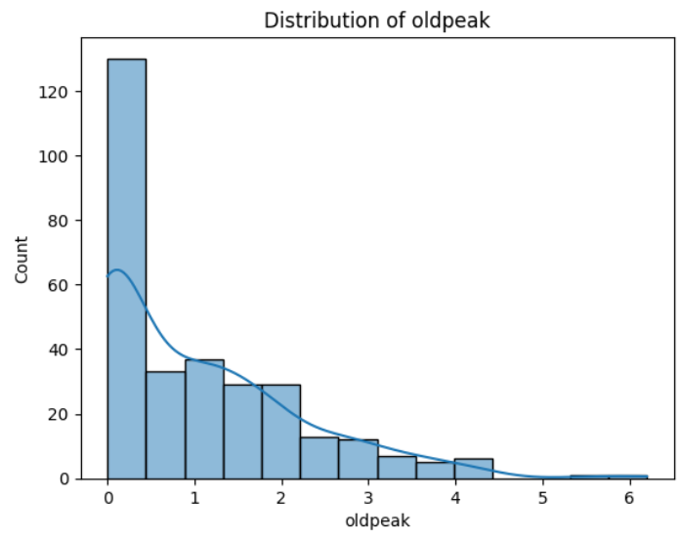
Figure4: Distribution of Cholesterol Figure5: Distribution of ST Depression
5.2.2 Bivariate Analysis
Bivariate analysis was conducted to investigate relationships between features and the target variable. Pairplots and grouped visualisations were used to compare distributions of variables such as age, cholesterol, and maximum heart rate with respect to heart disease presence.
The analysis showed that patients with lower maximum heart rate tended to have a higher likelihood of heart disease. Similarly, individuals with higher ST depression values were more likely to be classified as positive for heart disease. These relationships suggested that nonlinear interactions may exist, supporting the use of ensemble models such as Random Forest and XGBoost.
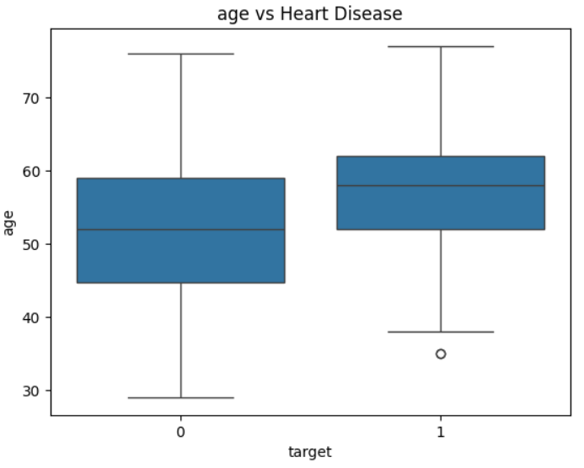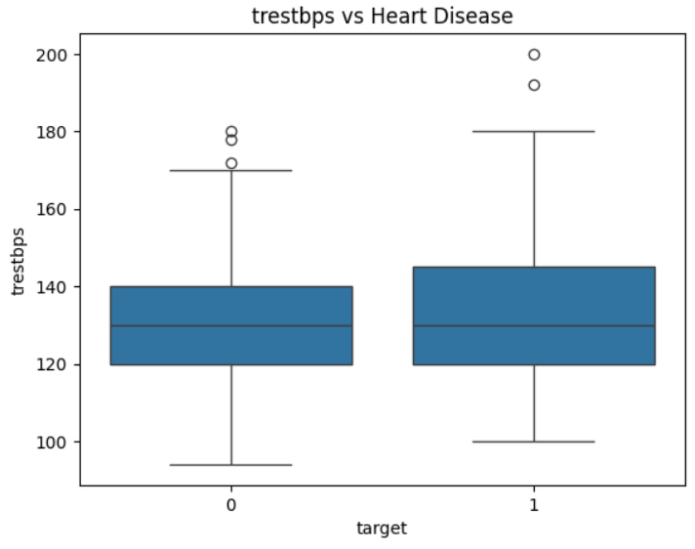
Figure6: Distribution of Patient Age Figure7: Resting Blood Pressure

5.2.3 Categorical Feature Analysis
Categorical features including chest pain type, sex, fasting blood sugar, exercise-induced angina, slope, and thalassemia were analysed using count plots.
The analysis revealed that asymptomatic chest pain type had the highest association with heart disease. Male patients showed a slightly higher prevalence of heart disease compared to female patients. Exercise-induced angina was also strongly associated with heart disease presence. These findings highlighted the importance of categorical features and justified retaining them in the model.
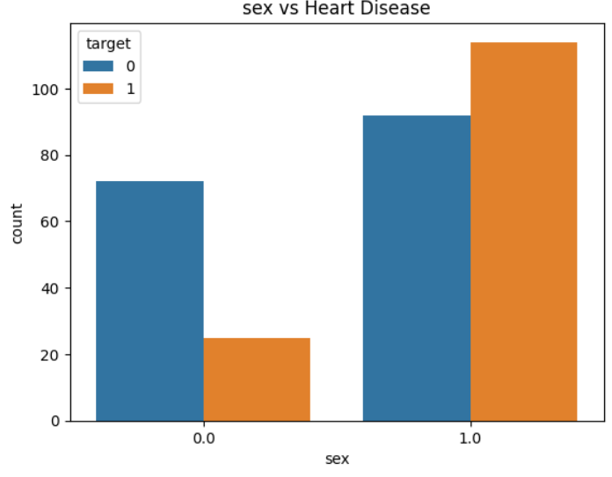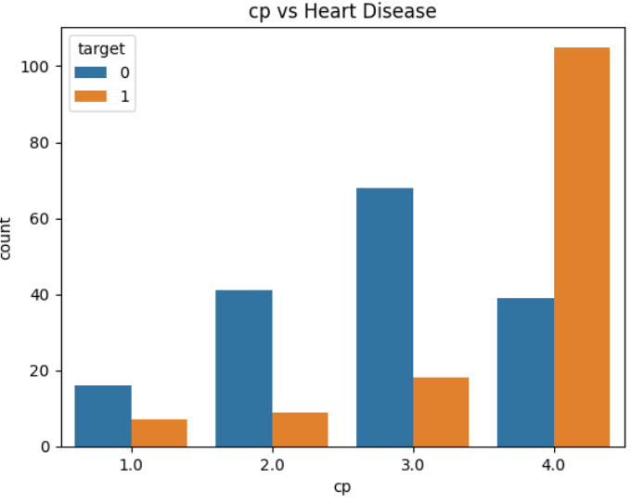
Figure8: Count plot of gender distribution Figure9: Count plot of chest pain type
categories
5.2.4 Correlation Analysis
A correlation heatmap was generated to examine relationships between numerical variables. The analysis showed that maximum heart rate had a moderate negative correlation with heart disease, while ST depression exhibited a positive correlation. Age and cholesterol showed weaker correlations.
Correlation between independent variables was generally low, indicating minimal multicollinearity. Since no strong correlations were observed among predictor variables, all features were retained for model training without dimensionality reduction.
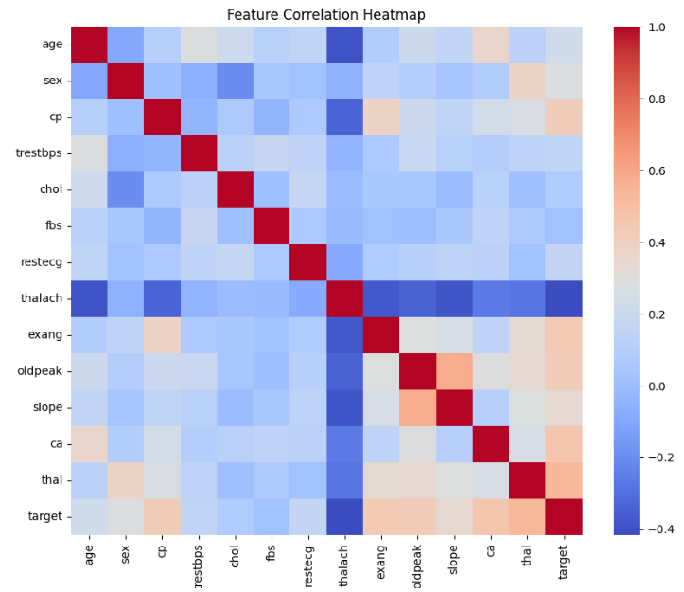
Figure10: Heatmap of correlation between features
5.2.5 Outlier Analysis
Boxplots were used to detect outliers in numerical features such as cholesterol, resting blood pressure, and ST depression. Several outliers were observed, particularly in cholesterol values.
However, these outliers were retained because they may represent clinically significant extreme cases. Removing these values could reduce model generalisation ability in real-world scenarios. Instead of removal, feature scaling was applied to minimise their impact.
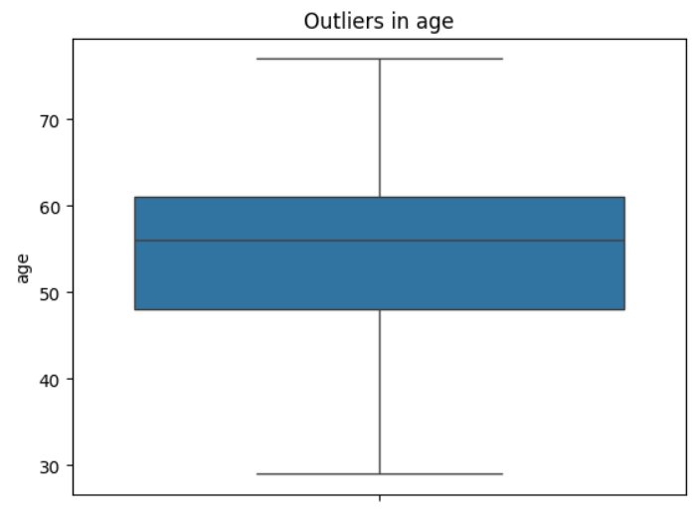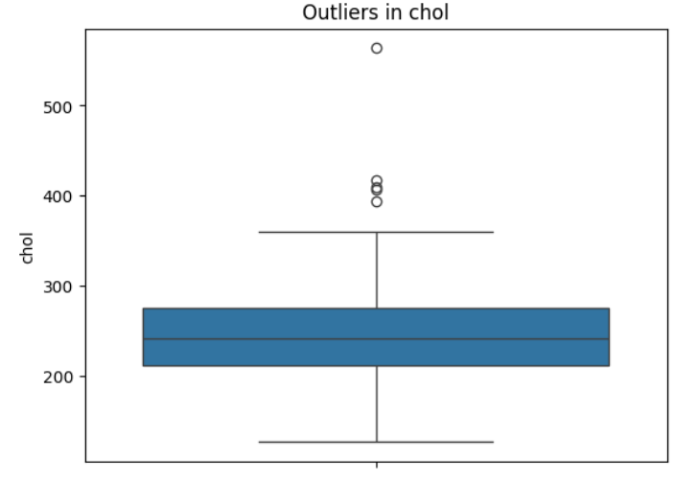
Figure11: Boxplot showing outliers in Figure12: Boxplot showing outliers in
Cholesterol resting blood pressure
5.3 Model Selection
Model selection was guided by insights obtained from exploratory data analysis, characteristics of the dataset, and findings from previous literature. The Cleveland Heart Disease dataset contains a mixture of numerical and categorical features, moderate dataset size (303 instances), and potential nonlinear relationships between predictors and the target variable. Therefore, a combination of baseline and ensemble machine learning models was selected to evaluate performance.
Three models were chosen: Logistic Regression, Random Forest, and XGBoost. These models represent linear, ensemble bagging, and ensemble boosting approaches respectively, allowing comparison across different learning paradigms.
5.3.1 Logistic Regression:
Logistic Regression was selected as a baseline model because it is widely used for binary classification problems and provides interpretable results. The model assumes a linear relationship between independent variables and the log-odds of the target variable. Since the dataset contains limited multicollinearity and scaled numerical features, Logistic Regression serves as a suitable baseline for comparison with more complex models.
Additionally, Logistic Regression performs well on smaller datasets and provides insights into feature importance through model coefficients. However, it may struggle to capture nonlinear relationships observed during exploratory data analysis.
5.3.2 Random Forest
Random Forest was selected as an ensemble bagging method capable of handling nonlinear relationships and interactions between features. The algorithm constructs multiple decision trees using bootstrap sampling and aggregates their predictions to reduce variance and improve generalisation.
EDA indicated that categorical features such as chest pain type and exercise-induced angina have nonlinear relationships with heart disease. Random Forest is well suited to capture such patterns. Furthermore, Random Forest is robust to outliers and does not require extensive feature scaling, making it appropriate for this dataset.
5.3.3 XGBoost
XGBoost was selected as a gradient boosting algorithm known for high predictive performance in classification tasks. Unlike Random Forest, XGBoost builds trees sequentially, where each tree corrects the errors of the previous one. This boosting approach improves model accuracy and reduces bias.
XGBoost is particularly effective for structured tabular data and can handle missing values, feature interactions, and nonlinear relationships. Previous studies in heart disease prediction have reported strong performance using boosting algorithms, which motivated its inclusion in this study.
5.4 Model Evaluation Metrics
To evaluate model performance comprehensively, multiple classification metrics were used. These metrics provide deeper insight than accuracy alone, particularly for medical diagnosis where false negatives are critical.
Accuracy
$$Accuracy=\frac{TP+TN}{TP+TN+FP+FN}$$

Precision
$$Precision=\frac{TP}{TP+FP}$$

Recall (Sensitivity)
$$Recall=\frac{TP}{TP+FN}$$
F1-Score
$$F1=2⋅\frac{Precision⋅Recall}{Precision+Recall}$$
A confusion matrix was also used to evaluate classification outcomes by visualising true positives, true negatives, false positives, and false negatives. This provided a detailed understanding of model error types.
Given the clinical context, greater emphasis was placed on recall and F1-score to ensure accurate identification of patients with heart disease.
5.5 Hyperparameter Tuning
To improve model performance and generalisation, hyperparameter tuning was performed using GridSearchCV, which systematically evaluates different parameter combinations using cross-validation to identify the optimal configuration.
For the Random Forest model, the parameter grid included:
- n_estimators: 100, 200 ,300
- max_depth: 4,6,8
For the XGBoost model, the parameter grid included:
- learning_rate: 0.01, 0.1
- max_depth: 3,4,5
GridSearchCV selected the best-performing models based on cross-validation scores. The optimal hyperparameters were:
- Random Forest: n_estimators = 200
- XGBoost: learning_rate = 0.1, max_depth = 5
Tuning Outcome
- Random Forest achieved improved stability after tuning.
- XGBoost showed minor improvement but remained below Logistic Regression in ROC-AUC performance.
- Logistic Regression was not tuned further as it already showed strong baseline performance.
5.6 Explainable AI using SHAP (Shapley Additive Explanations)
To improve interpretability of the machine learning models, Explainable Artificial Intelligence (XAI) techniques were applied using SHAP (SHapley Additive exPlanations), introduced by Lundberg and Lee (2017). SHAP is based on cooperative game theory and assigns each feature a Shapley value representing its contribution to a model’s prediction. It provides both global interpretability (overall feature importance) and local interpretability (individual prediction explanations).
SHAP analysis was first applied to the baseline (untuned) XGBoost model to understand initial feature behaviour. The results showed that features such as maximum heart rate achieved (thalach), ST depression (oldpeak), and chest pain type (cp) were the most influential predictors, although the feature importance distribution showed higher variability, indicating lower stability.
After hyperparameter tuning using GridSearchCV, SHAP was reapplied to the optimized XGBoost model. The same key features remained dominant, but their importance rankings became more stable and better defined, indicating improved model consistency.
A comparative analysis showed that hyperparameter tuning enhanced both model performance and interpretability by reducing noise in less important features and strengthening the contribution clarity of key clinical variables.
The SHAP results are consistent with medical domain knowledge, as the identified features are well-known indicators of heart disease risk. SHAP summary plots and feature importance visualisations further improved transparency by illustrating how each feature influences predictions.
Overall, SHAP enhances model explainability and ensures that the final model is both accurate and interpretable, making it suitable for healthcare decision-support applications. 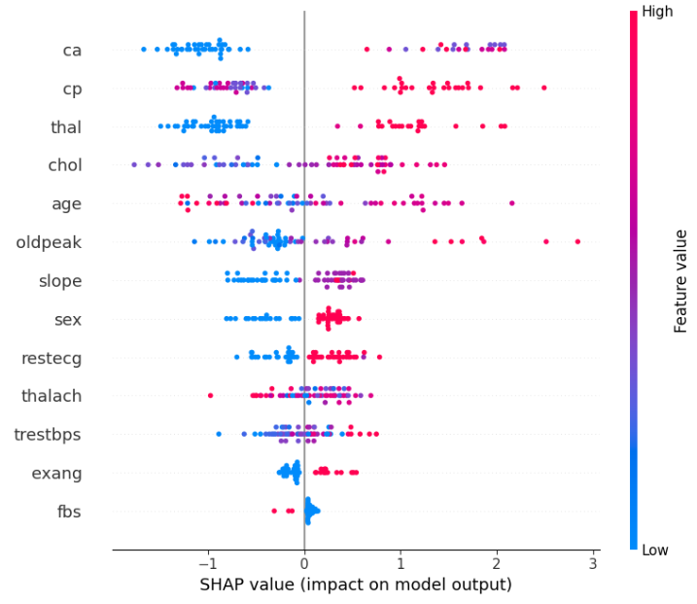 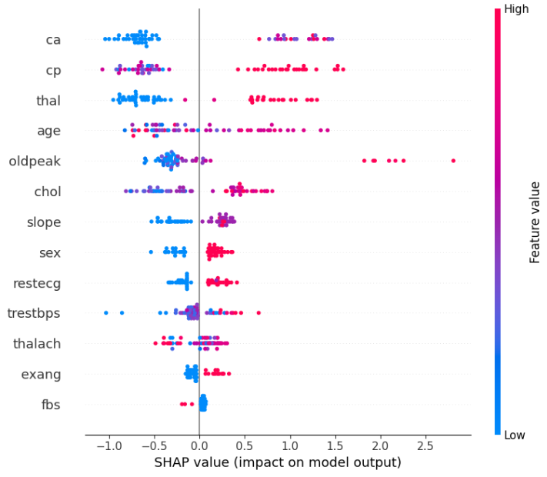
Figure13: SHAP Summary Plot Figure14: SHAP Summary Plot
(Baseline Model) (Tuned Model)

6. RESULTS & DISCUSSION
6.1 Model Performance Comparison
Model | Accuracy | Precision | Recall | F1-score | ROC-AUC
Logistic Regression | 83% | 0.85 | 0.79 | 0.81 | 0.95
Random Forest | 87% | 0.88 | 0.82 | 0.85 | 0.95
XGBoost | 87% | 0.88 | 0.82 | 0.85 | 0.89

6.2 ROC Curve Analysis
ROC curve analysis was conducted to evaluate model performance before and after hyperparameter tuning, providing insight into how optimisation improved classification ability.
The ROC curve plots the True Positive Rate (Sensitivity) against the False Positive Rate across different decision thresholds. The Area Under the Curve (AUC) was used as a summary measure, where a higher AUC indicates better discrimination between patients with and without heart disease.
6.2.1 Before Hyperparameter Tuning
Before hyperparameter optimisation, the models showed the following performance patterns:
- Logistic Regression achieved the highest ROC-AUC (~0.95), indicating excellent ability to distinguish between the two classes.
- Random Forest performed closely with a ROC-AUC of approximately 0.945, showing strong but slightly lower discrimination ability.
- XGBoost achieved the lowest ROC-AUC (~0.89), suggesting weaker class separation compared to the other models in its initial configuration.
These results indicate that even the simpler linear model (Logistic Regression) was highly effective for this dataset.
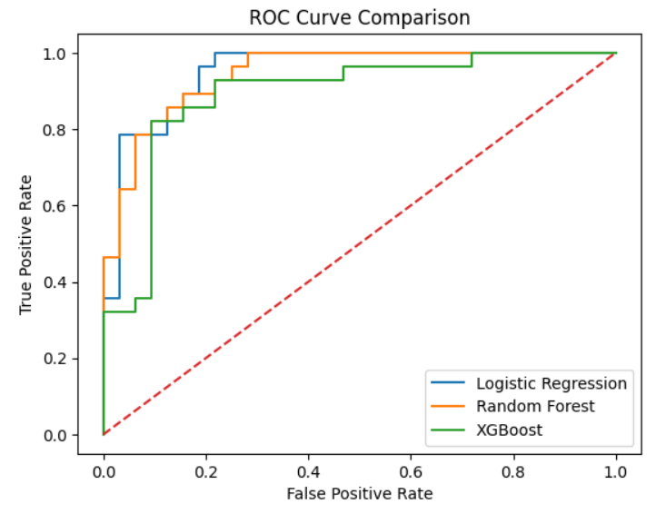
Figure15: ROC curves for baseline models
6.2.2 After Hyperparameter Tuning
After applying GridSearchCV-based hyperparameter tuning:
- Random Forest showed a slight improvement in stability and consistency of predictions, although gains in ROC-AUC were marginal.
- XGBoost improved slightly due to optimised parameters but still remained the weakest model in terms of ROC-AUC.
- Logistic Regression remained unchanged and consistently achieved the strongest performance overall.
Overall, tuning improved the robustness of ensemble models but did not significantly change the ranking of model performance.
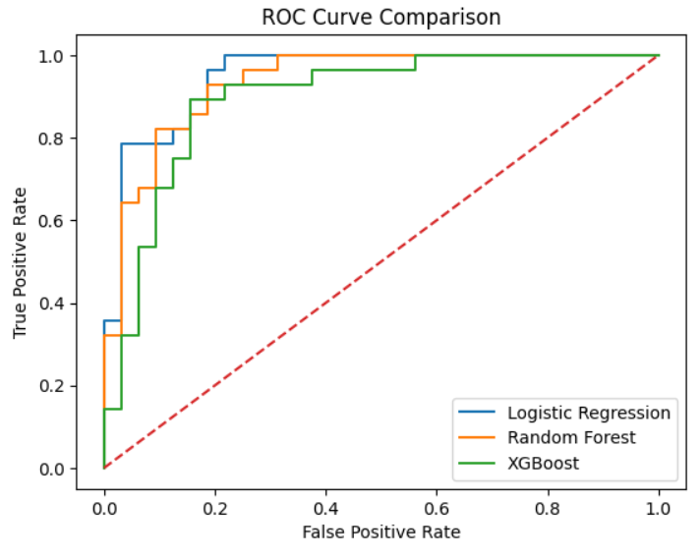
Figure16: ROC curves for tuned models after hyperparameter optimization
6.3 Interpretation
ROC curve analysis confirms that Logistic Regression provides the best overall balance of sensitivity (true positive rate) and specificity (true negative rate) for this dataset. This indicates that the relationship between features and heart disease outcome is largely linear in nature, allowing a simpler model to outperform more complex ensemble methods in terms of discrimination ability.
The results also suggest that model complexity does not always lead to improved performance, particularly in relatively small and well-structured medical datasets such as the Cleveland Heart Disease dataset. Ensemble models still provide competitive performance, but their advantage is limited in this case due to the strong linear separability captured effectively by Logistic Regression.
6.4 Key Findings
- Logistic Regression is the best model for ROC-AUC performance
- Random Forest provides a strong balance between accuracy and interpretability
- XGBoost performs well but is not the strongest for this dataset
- Feature relationships appear largely linear, explaining Logistic Regression’s strong performance
- Important predictors include:
  - Chest pain type (cp)
  - Maximum heart rate (thalach)
  - ST depression (oldpeak)
7. CONCLUSION
This project demonstrates that machine learning models can effectively predict heart disease risk using clinical data. Among the tested models, Logistic Regression achieved the best ROC-AUC performance, showing strong predictive capability despite its simplicity.
Ensemble models such as Random Forest and XGBoost provided competitive accuracy, but did not outperform Logistic Regression in overall discrimination ability.
Explainability techniques such as SHAP confirmed that clinically relevant features such as chest pain type and maximum heart rate are key predictors of heart disease, aligning with medical knowledge.
Overall, the study shows that interpretable models can be highly effective for medical prediction tasks, especially when datasets are small and structured.

8. FUTURE WORK
Future work can focus on improving dataset size and diversity by using larger multi-hospital datasets to enhance model generalisation and reduce potential bias. This would help ensure more reliable performance across different patient populations.
Advanced machine learning techniques, including deep learning models such as neural networks, could be explored to capture more complex and nonlinear relationships in clinical data. Hybrid models combining machine learning and deep learning may also be considered.
The system can be further developed into a fully functional web application using frameworks such as Flask or Streamlit, enabling real-time heart disease risk prediction and improving accessibility for clinical decision support.
Improved feature engineering techniques, such as interaction terms, feature selection methods, and dimensionality reduction (e.g., PCA), may further enhance model performance and interpretability.
Additionally, model explainability can be expanded using advanced XAI techniques beyond SHAP to increase clinical trust and usability.
Finally, external validation using real-world hospital datasets is essential to test robustness, ensure clinical reliability, and confirm the model’s applicability in real healthcare environments.

REFERENCES
[1] Breiman, L. (2001) ‘Random Forests’, Machine Learning, 45(1), pp. 5–32.
[2] Chen, T. and Guestrin, C. (2016) ‘XGBoost: A scalable tree boosting system’, Proceedings of the 22nd ACM SIGKDD International Conference, pp. 785–794.
[3] Lundberg, S.M. and Lee, S.I. (2017) ‘A unified approach to interpreting model predictions’, Advances in Neural Information Processing Systems, 30, pp. 4765–4774.
[4] Rajpurkar, P. et al. (2017) ‘CheXNet: Radiologist-level pneumonia detection’, arXiv:1711.05225.
[5]Yang, J. and Guan, X. (2022) ‘Improved heart disease prediction using SMOTE and XGBoost’, Information, 13(10), p. 475.

APPENDIX
import numpy as np
import pandas as pd
import matplotlib.pyplot as plt
import seaborn as sns
from sklearn.model_selection import train_test_split, GridSearchCV
from sklearn.preprocessing import StandardScaler
from sklearn.impute import SimpleImputer
from sklearn.pipeline import Pipeline
from sklearn.linear_model import LogisticRegression
from sklearn.ensemble import RandomForestClassifier
from xgboost import XGBClassifier
from sklearn.metrics import accuracy_score, confusion_matrix, roc_auc_score, roc_curve
from sklearn.metrics import precision_score, recall_score, f1_score

column_names = [
"age", "sex", "cp", "trestbps", "chol",
"fbs", "restecg", "thalach", "exang",
"oldpeak", "slope", "ca", "thal", "target"
]

df = pd.read_csv(
"/content/drive/MyDrive/processed.cleveland.data",
names=column_names,
na_values="?"
)

df.head()
print("Dataset shape:", df.shape)
df.info()
missing_values = df.isnull().sum()
missing_values = missing_values[missing_values > 0]
print(missing_values)
total_missing = df.isnull().sum().sum()
print("Total missing values in dataset:", total_missing)
missing_values.plot(kind='bar')
plt.title("Missing Values Count")
plt.ylabel("Count")
plt.xlabel("Features")
plt.show()
df["target"] = df["target"].apply(lambda x: 1 if x > 0 else 0)
df["target"].value_counts()
sns.countplot(x="target", data=df)
plt.xlabel("Heart Disease (0 = No, 1 = Yes)")
plt.ylabel("Count")
plt.title("Target Variable Distribution")
plt.show()
df.describe()
numerical_features = ["age", "trestbps", "chol", "thalach", "oldpeak"]

for col in numerical_features:
plt.figure()
sns.histplot(df[col], kde=True)
plt.title(f"Distribution of {col}")
plt.show()

for col in numerical_features:
plt.figure()
sns.boxplot(x="target", y=col, data=df)
plt.title(f"{col} vs Heart Disease")
plt.show()

categorical_features = ["sex", "cp", "exang", "slope", "thal"]

for col in categorical_features:
plt.figure()
sns.countplot(x=col, hue="target", data=df)
plt.title(f"{col} vs Heart Disease")
plt.show()
plt.figure(figsize=(10, 8))
sns.heatmap(df.corr(), cmap="coolwarm", annot=False)
plt.title("Feature Correlation Heatmap")
plt.show()
for col in numerical_features:
plt.figure()
sns.boxplot(y=df[col])
plt.title(f"Outliers in {col}")
plt.show()
df = df.replace("?", np.nan)
df = df.apply(pd.to_numeric)
df = df.dropna()
X = df.drop("target", axis=1)
y = df["target"]

X_train, X_test, y_train, y_test = train_test_split(
X, y, test_size=0.2, random_state=42, stratify=y
)

scaler = StandardScaler()
X_train_scaled = scaler.fit_transform(X_train)
X_test_scaled = scaler.transform(X_test)
from sklearn.metrics import classification_report

# Impute missing values with the mean before scaling
imputer = SimpleImputer(strategy='mean')
X_train_imputed = imputer.fit_transform(X_train)
X_test_imputed = imputer.transform(X_test)

# Re-apply scaling on the imputed data
scaler = StandardScaler()
X_train_scaled = scaler.fit_transform(X_train_imputed)
X_test_scaled = scaler.transform(X_test_imputed)

log_reg = LogisticRegression(max_iter=1000)
log_reg.fit(X_train_scaled, y_train)

y_pred_lr = log_reg.predict(X_test_scaled)
y_prob_lr = log_reg.predict_proba(X_test_scaled)[:, 1]

print("Logistic Regression Accuracy:", accuracy_score(y_test, y_pred_lr))
print("Logistic Regression ROC-AUC:", roc_auc_score(y_test, y_prob_lr))
print(classification_report(y_test, y_pred_lr))
from sklearn.metrics import ConfusionMatrixDisplay

ConfusionMatrixDisplay.from_predictions(y_test, y_pred_lr)
plt.title("Logistic Regression Confusion Matrix")
plt.show()
rf = RandomForestClassifier(
n_estimators=200,
random_state=42
)

rf.fit(X_train, y_train)

y_pred_rf = rf.predict(X_test)
y_prob_rf = rf.predict_proba(X_test)[:, 1]

print("Random Forest Accuracy:", accuracy_score(y_test, y_pred_rf))
print("Random Forest ROC-AUC:", roc_auc_score(y_test, y_prob_rf))
print(classification_report(y_test, y_pred_rf))

xgb = XGBClassifier(
n_estimators=200,
learning_rate=0.1,
max_depth=4,
random_state=42,
eval_metric="logloss"
)

xgb.fit(X_train, y_train)

y_pred_xgb = xgb.predict(X_test)
y_prob_xgb = xgb.predict_proba(X_test)[:, 1]

print("XGBoost Accuracy:", accuracy_score(y_test, y_pred_xgb))
print("XGBoost ROC-AUC:", roc_auc_score(y_test, y_prob_xgb))
print(classification_report(y_test, y_pred_xgb))
plt.figure()

for model, X_data, name in [
(log_reg, X_test_scaled, "Logistic Regression"),
(rf, X_test, "Random Forest"),
(xgb, X_test, "XGBoost")
]:
y_prob = model.predict_proba(X_data)[:,1]
fpr, tpr, _ = roc_curve(y_test, y_prob)
plt.plot(fpr, tpr, label=name)

plt.plot([0,1],[0,1],'--')
plt.xlabel("False Positive Rate")
plt.ylabel("True Positive Rate")
plt.title("ROC Curve Comparison")
plt.legend()
plt.show()
import shap

explainer = shap.Explainer(xgb, X_train)
shap_values = explainer(X_test)
shap.summary_plot(shap_values, X_test, plot_type="bar")
shap.dependence_plot("thalach", shap_values.values, X_test)
rf = RandomForestClassifier(random_state=42)

param_grid_rf = {
"n_estimators": [100, 200, 300],
"max_depth": [None, 4, 6, 8],
"min_samples_split": [2, 5, 10]
}

grid_rf = GridSearchCV(
rf,
param_grid_rf,
cv=5,
scoring="roc_auc",
n_jobs=-1
)

grid_rf.fit(X_train, y_train)

best_rf = grid_rf.best_estimator_

print("Best Random Forest Parameters:")
print(grid_rf.best_params_)
xgb = XGBClassifier(eval_metric="logloss", random_state=42)

param_grid_xgb = {
"n_estimators": [100, 200],
"max_depth": [3, 4, 5],
"learning_rate": [0.01, 0.05, 0.1]
}

grid_xgb = GridSearchCV(
xgb,
param_grid_xgb,
cv=5,
scoring="roc_auc",
n_jobs=-1
)

grid_xgb.fit(X_train, y_train)

best_xgb = grid_xgb.best_estimator_

print("Best XGBoost Parameters:")
print(grid_xgb.best_params_)

def evaluate_model(y_test, y_pred, model_name):
print(f"\n{model_name}")
print("Accuracy:", accuracy_score(y_test, y_pred))
print("Precision:", precision_score(y_test, y_pred))
print("Recall:", recall_score(y_test, y_pred))
print("F1 Score:", f1_score(y_test, y_pred))
print("ROC-AUC:", roc_auc_score(y_test, y_pred))

cm = confusion_matrix(y_test, y_pred)
sns.heatmap(cm, annot=True, fmt='d')
plt.title(model_name)
plt.show()
evaluate_model(y_test, y_pred_lr, "Logistic Regression")
evaluate_model(y_test, y_pred_rf, "Random Forest")
evaluate_model(y_test, y_pred_xgb, "XGBoost")
plt.figure()

models = [
("Logistic Regression", log_reg, X_test_scaled),
("Random Forest", best_rf, X_test),
("XGBoost", best_xgb, X_test)
]

for name, model, X_data in models:

y_prob = model.predict_proba(X_data)[:,1]
fpr, tpr, _ = roc_curve(y_test, y_prob)

plt.plot(fpr, tpr, label=name)

plt.plot([0,1],[0,1],'--')

plt.xlabel("False Positive Rate")
plt.ylabel("True Positive Rate")
plt.title("ROC Curve Comparison")
plt.legend()

plt.show()
from sklearn.metrics import ConfusionMatrixDisplay

ConfusionMatrixDisplay.from_predictions(y_test, y_pred_xgb)

plt.title("Confusion Matrix - XGBoost")
plt.show()
feature_importance = pd.Series(
best_xgb.feature_importances_,
index=X.columns
).sort_values(ascending=False)

feature_importance.plot(kind="bar")

plt.title("Feature Importance - XGBoost")
plt.ylabel("Importance Score")

plt.show()
explainer = shap.Explainer(best_xgb, X_train)
shap_values = explainer(X_test)
shap.summary_plot(shap_values, X_test)
shap.dependence_plot("thalach", shap_values.values, X_test)

